Marco Seman

CIS 310 Program 4

Professor: David Yoon

Due Date: April 4, 2018

Description:

Write a C++ program which performs +, -, \*, / and $ on hexadecimal operands. The maximum length of any operand or a solution is 40 digits.

Documentation of the test cases:

1)

AAAA+BBF

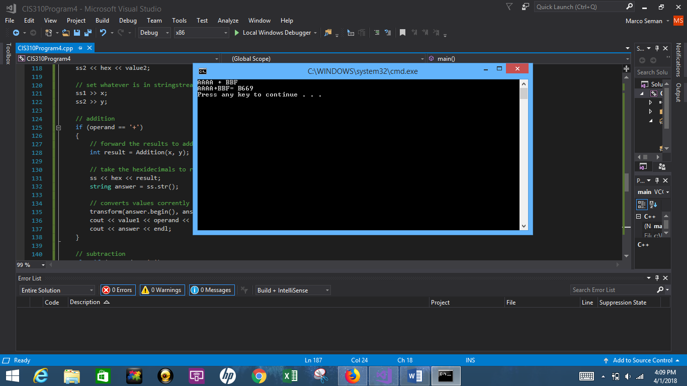

2)

BFD+2DE

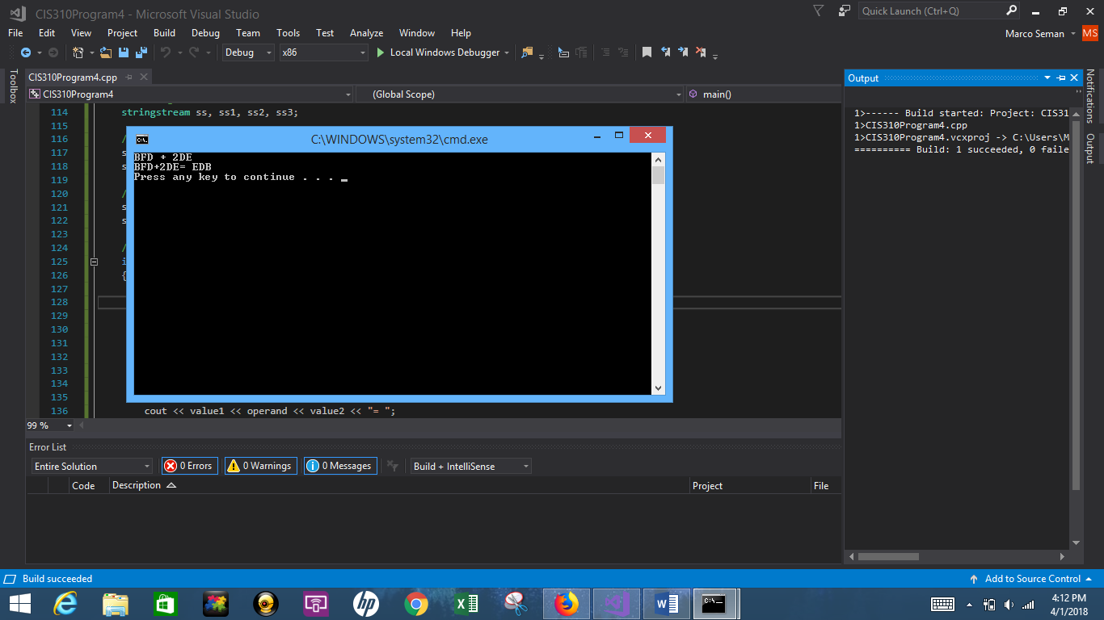

3)

100\*AA

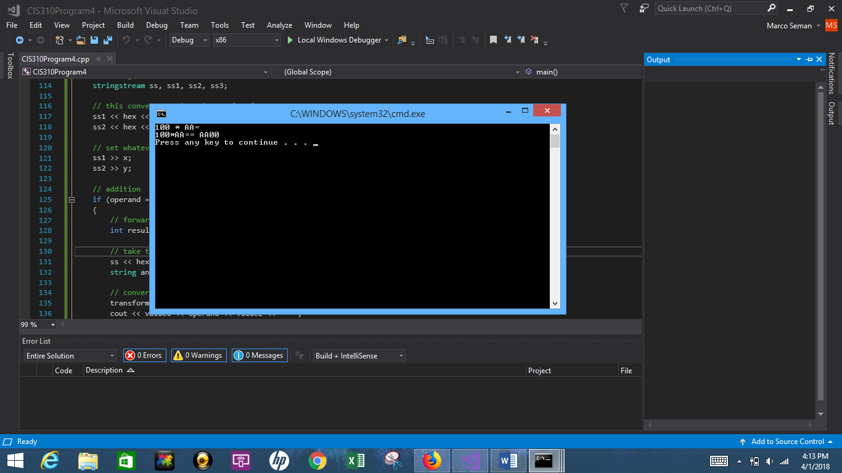

4)

100 $ 5

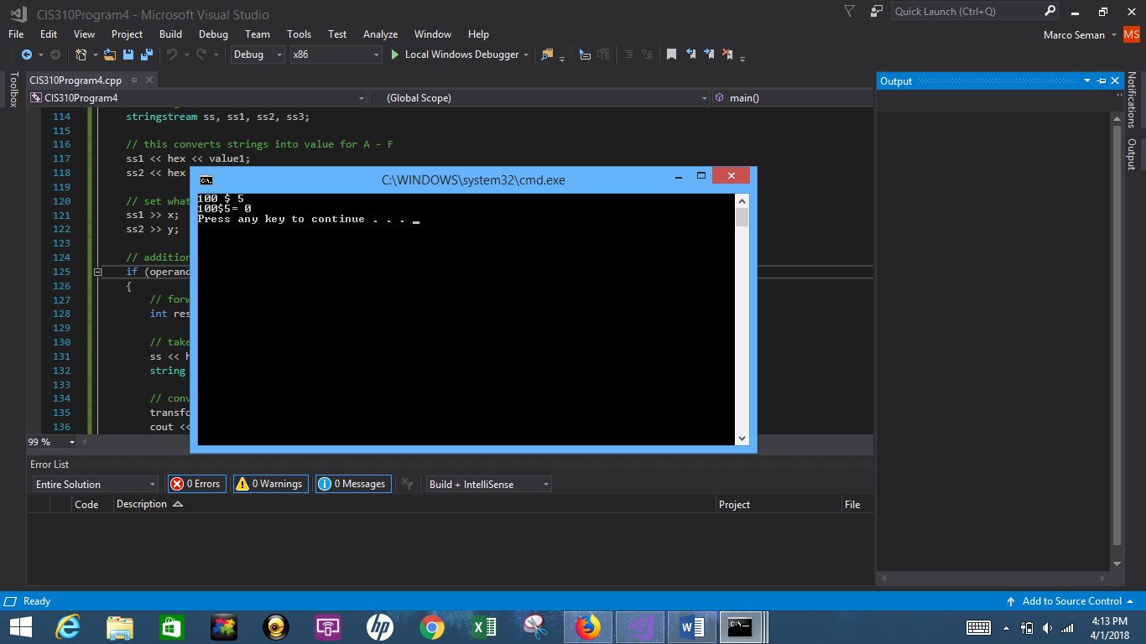

5)

100/F

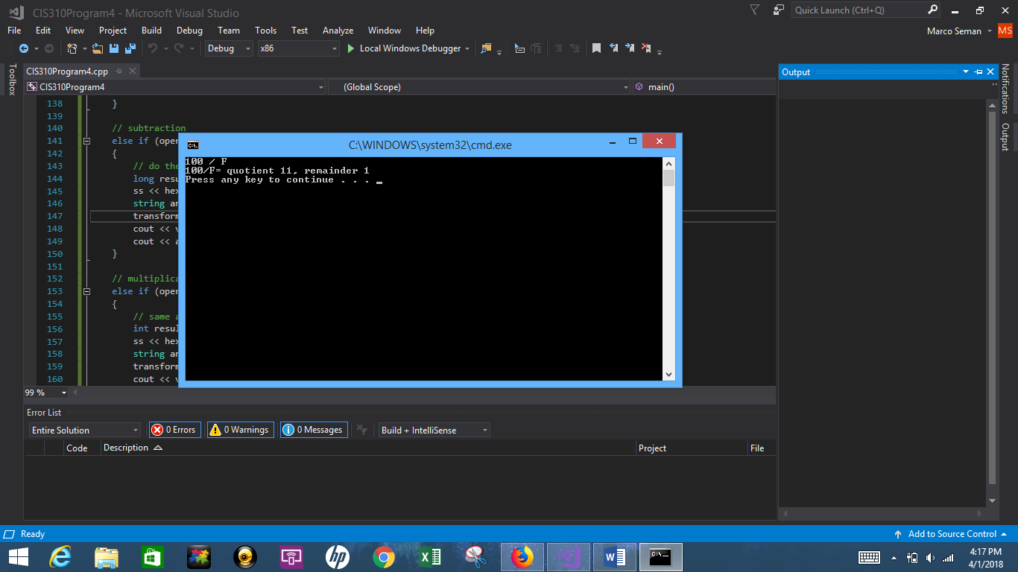

6)

10000000000000 - 1

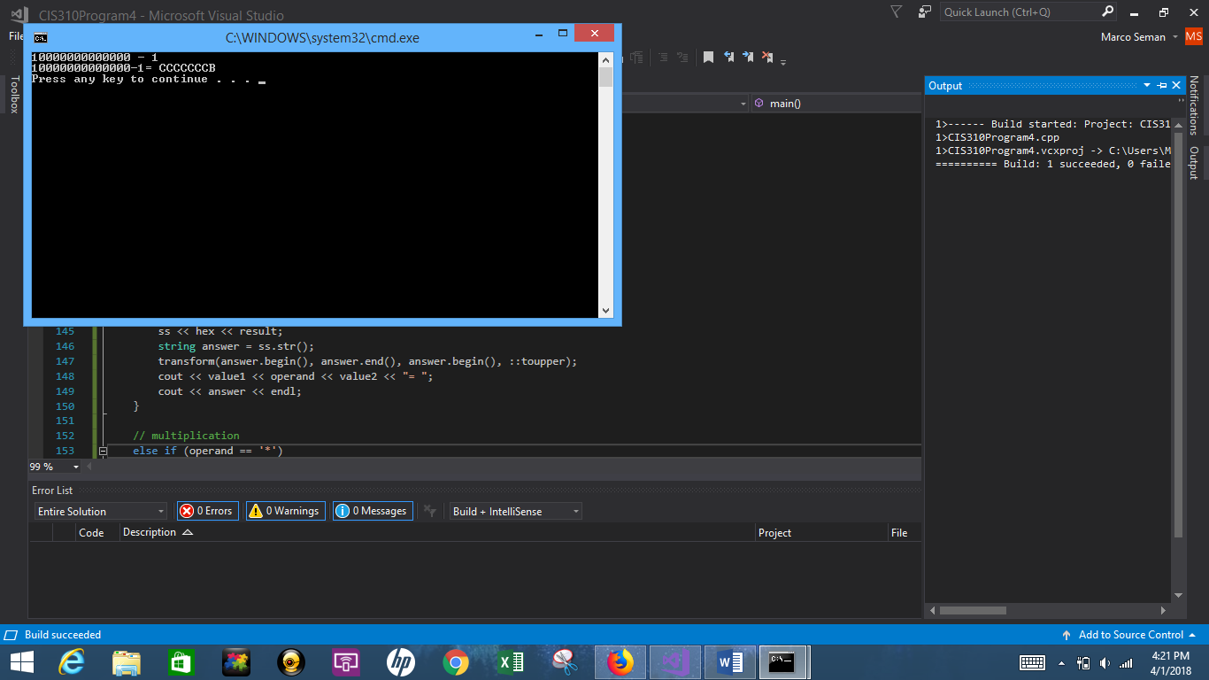

7)

AAAAABBBBBCCCCCDDDDDEEEEEFFFFF - ABCDEF0123456789ABC

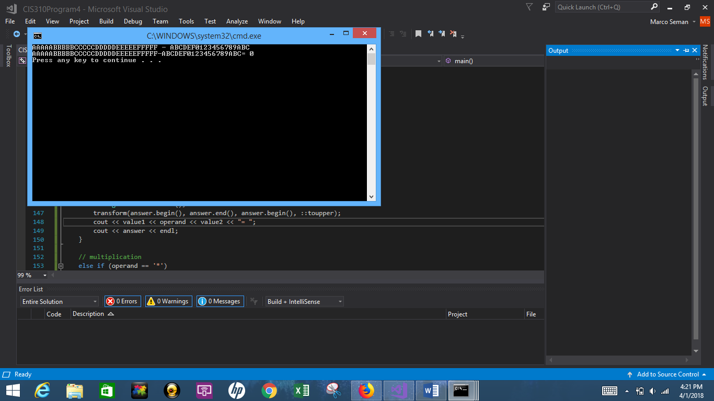

8)

FACDFDB1 / 45CDF52

